DSYS601
REST vs. RESTCONF

Contents
1. Introduction 2
2. REST vs. RESTCONF 3
2.1 REST (Representational State Transfer) 3
2.1.1 Definition 3
2.1.2 Key Characteristics 3
2.1.3 Use Case 3
2.1.4 Flexibility 3
2.2 RESTCONF (RESTful Configuration Protocol) 3
2.2.1 Definition 3
2.2.2 Key Characteristics 3
2.2.3 Features 4
2.2.4 Use Case 4
2.2.5 Constraints 4
3. Comparison Table 4
4. Summary 4

Introduction

REST is an architecture that uses APIs over HTTP.
This is not the only method of implementing APIs over HTTP.
Below are several options:

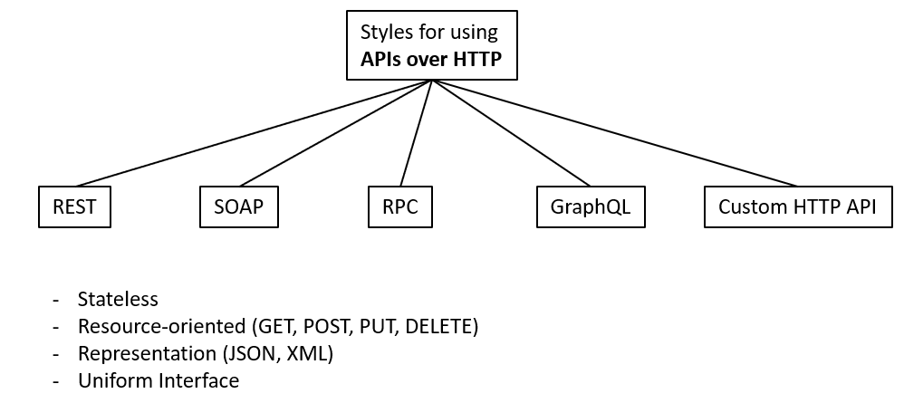

REST vs. RESTCONF

REST and RESTCONF are related but distinct in their scope, usage, and design. Here's a comparison to highlight the differences:

2.1 REST (Representational State Transfer)

2.1.1 Definition

- REST is an architectural style for designing networked applications. It is not a protocol but a set of principles that guide API design.

2.1.2 Key Characteristics

- Stateless communication between client and server.
- Resource-oriented: Resources are identified by URIs and manipulated using HTTP methods (GET, POST, PUT, DELETE, etc.).
- Utilises standard HTTP mechanisms for communication (status codes, headers, methods).
- Data can be represented in various formats (e.g., JSON, XML).

2.1.3 Use Case

- General-purpose API design across various domains (e.g., web services, e-commerce APIs).

2.1.4 Flexibility

- REST does not prescribe a strict schema or specific payload structure.

2.2 RESTCONF (RESTful Configuration Protocol)

2.2.1 Definition

- RESTCONF is a protocol that uses REST principles specifically for managing and configuring network devices and systems.
- It is standardised by the IETF (Internet Engineering Task Force) in RFC 8040.

2.2.2 Key Characteristics

- Built on top of REST principles but tailored for network configuration and management.
- Operates over HTTP/HTTPS.
- Uses YANG models to define data structures and configuration/state data.
- YANG is a data modelling language for defining network device configurations and operational state.

2.2.3 Features
- Provides standardized operations to:
- Retrieve configuration and state data (GET).
- Modify configurations (POST, PUT, DELETE).
- Perform RPCs and actions on resources.
- Supports the NETCONF datastore concepts (e.g., candidate, running, startup configurations).

2.2.4 Use Case

- Specifically designed for managing network devices, such as routers and switches, in environments that leverage NETCONF and YANG.

2.2.5 Constraints

- RESTCONF assumes a well-defined data model (via YANG), making it more structured and less flexible than generic REST APIs.

Comparison Table

Feature | REST | RESTCONF
Scope | General-purpose API design. | Network configuration and management.
Standardisation | No specific standard body. | Defined by IETF (RFC 8040).
Underlying Model | No fixed model, resource-oriented. | Uses YANG for data modelling.
Flexibility | Flexible, supports any domain. | Tailored to network devices.
Focus | Broad application development. | Network management tasks.
Data Representation | JSON, XML, etc. | JSON or XML, based on YANG.

Summary

- REST is a general-purpose architecture for designing APIs, while RESTCONF is a specialised protocol for managing network devices using REST principles combined with NETCONF and YANG.
- RESTCONF’s strict adherence to YANG models and focus on network configuration makes it highly suitable for SDN (Software-Defined Networking) and modern network automation scenarios.

